**Hands-On: Stage 3 - C# Additional Topics Async Programming, Multithreading - Day 3 – Handson 2**

**Multithreading – ThreadStart (ThreadStartSample)**

**Printer.cs**

using System;

using System.Collections.Generic;

using System.Text;

using System.Threading;

namespace ThreadStartSample

{

    class Printer

    {

        public void PrintNumbers()

        {

            // Display Thread info.

            Console.WriteLine("-> {0} is executing PrintNumbers()", Thread.CurrentThread.Name);

            // Print out numbers.

            Console.Write("Your numbers: ");

            for (int i = 0; i < 10; i++)

            {

                Console.Write("{0}, ", i);

                Thread.Sleep(2000);

            }

            Console.WriteLine();

        }

    }

}

**Program.cs**

using System;

using System.Threading;

namespace ThreadStartSample

{

    class Program

    {

        static void Main(string[] args)

        {

            Console.WriteLine("*****ThreadStart Delegate App*****\n");

            Console.Write("Do you want [1] or [2] threads? ");

            string threadCount = Console.ReadLine();

            // Name the current thread.

            Thread primaryThread = Thread.CurrentThread;

            primaryThread.Name = "Primary";

            // Display Thread info.

            Console.WriteLine("-> {0} is executing Main()", Thread.CurrentThread.Name);

            // Make worker class.

            Printer p = new Printer();

            switch (threadCount)

            {

                case "2":

                    // Now make the thread.

                    Thread backgroundThread = new Thread(new ThreadStart(p.PrintNumbers));

                    backgroundThread.Name = "Secondary";

                    backgroundThread.Start();// Changes the state of current instance to ThreadState.Running.

                    break;

                case "1":

                    p.PrintNumbers();

                    break;

                default:

                    Console.WriteLine("I don't know what you want... you get 1 thread.");

                    goto case "1";

            }

            // Do some additional work.

            Console.WriteLine("Hello this from main!");

        }

    }

}

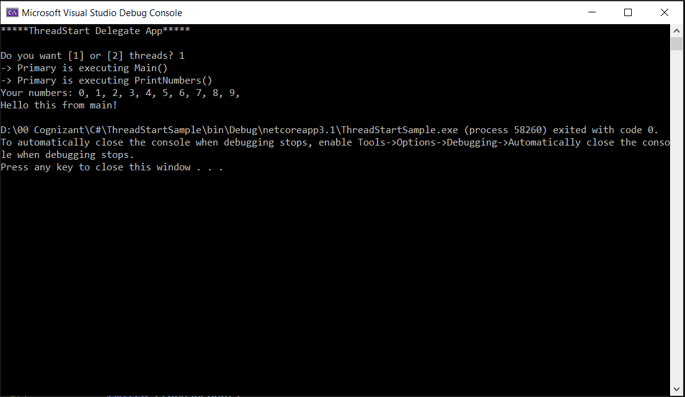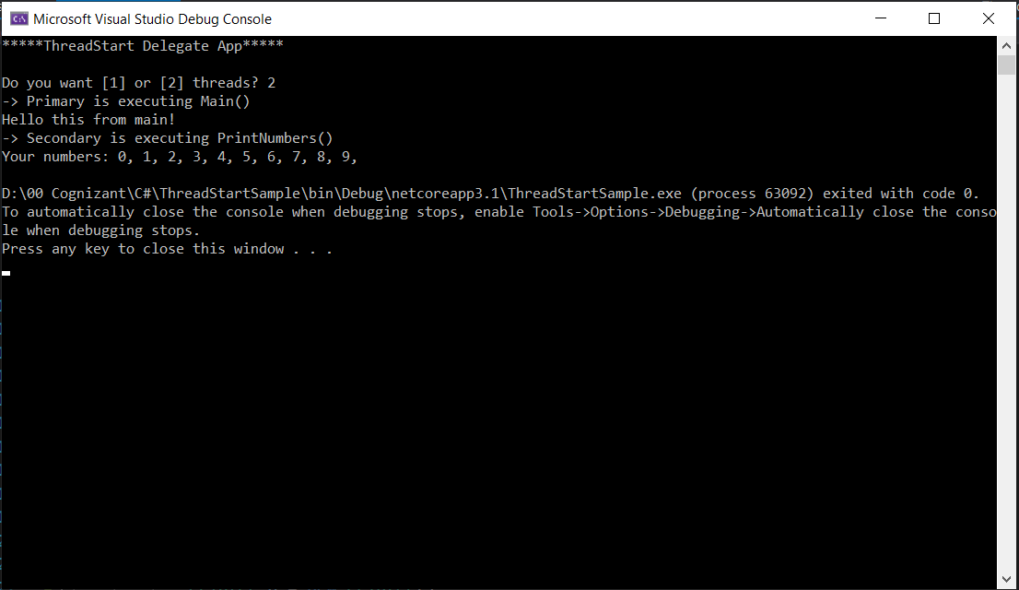**OUTPUT**

**Multithreading – ThreadStart (MultithreadingSample)**

**Printer.cs**

using System;

using System.Threading;

namespace MultithreadingSample

{

    class Printer

    {

        private object lockToken = new object();

        public void PrintNumbers()

        {

                lock (lockToken)

                {

                    // Display Thread info.

                    Console.WriteLine("Thread-> {0} started @{1} and executing PrintNumbers() method",

                        Thread.CurrentThread.ManagedThreadId, DateTime.Now.ToLongTimeString());

                    // Print out numbers.

                    Console.Write("Your numbers: ");

                    for (int i = 0; i < 10; i++)

                    {

                        Console.Write("{0}, ", i);

                        Thread.Sleep(500);

                    }

                    Console.WriteLine();

                }

        }

    }

}

**Program.cs**

using System;

using System.Threading;

namespace MultithreadingSample

{

    class Program

    {

        static void PrintTheNumbers(object state)

        {

            Printer task = (Printer)state;

            task.PrintNumbers();

        }

        static void Main(string[] args)

        {

            Console.WriteLine("*****Multithreading Program*****\n");

            Console.WriteLine("Main thread started. ThreadID = {0}",

                Thread.CurrentThread.ManagedThreadId);

            Printer p = new Printer();

            WaitCallback workItem = new WaitCallback(PrintTheNumbers);

            // Queue the method 10 times.

            for (int i = 0; i < 10; i++)

            {

                ThreadPool.QueueUserWorkItem(workItem, p);

            }

            Console.WriteLine("All task Queued");

            Console.ReadLine();

        }

    }

}

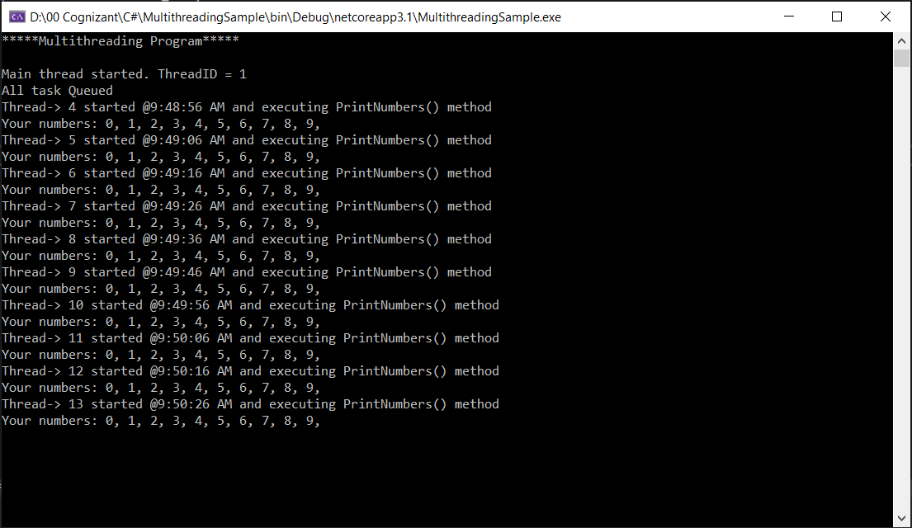**OUTPUT**